1) Create a more comprehensive low fidelity prototype.

What type of prototype/method are you going to use? What is the prototype describing? How has your research from last week informed your prototype?

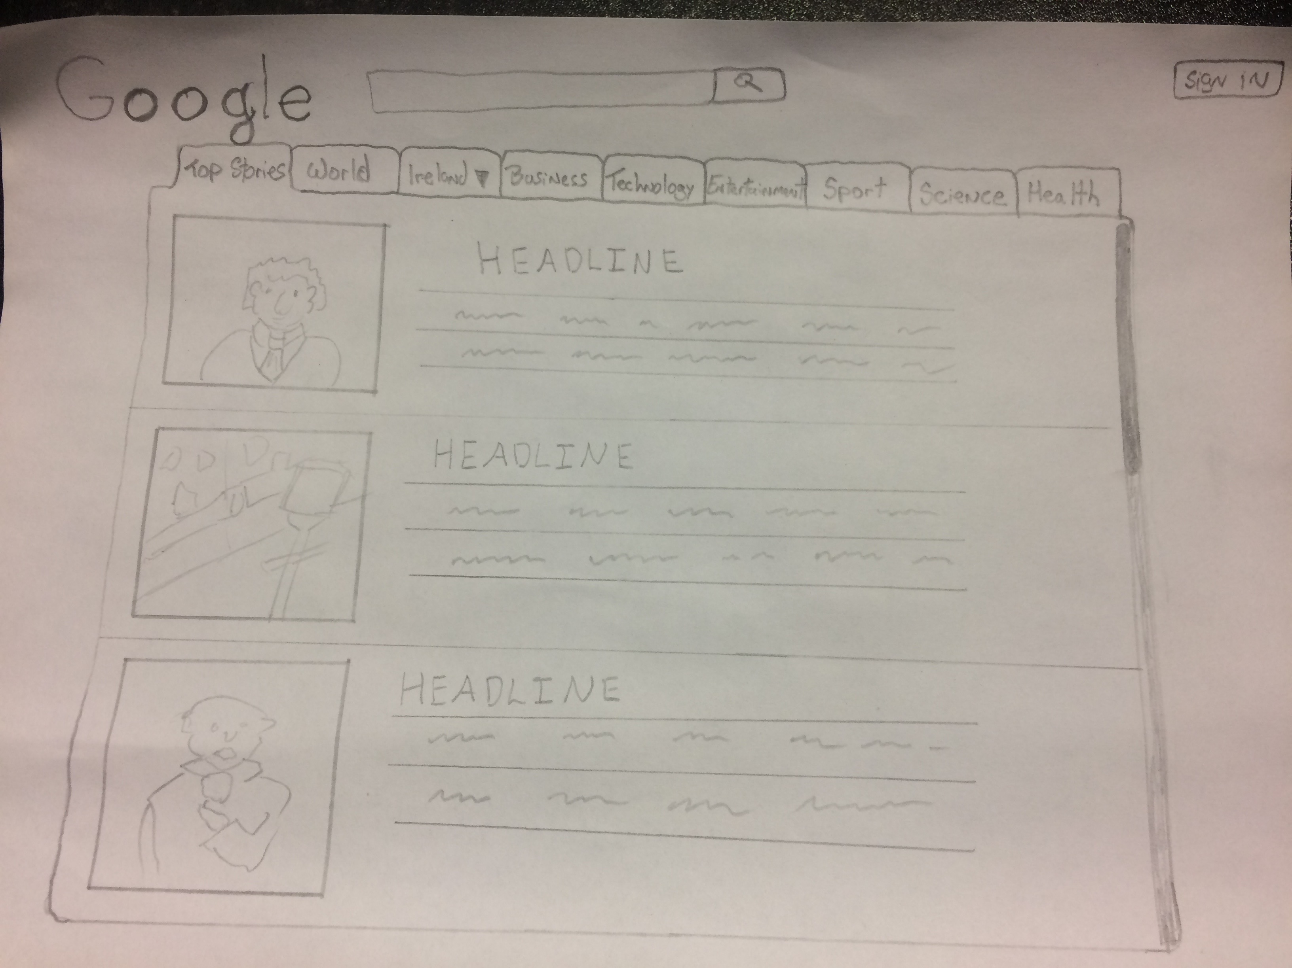

We are using evolutionary prototyping as our prototype method. The reason for this is because we have not discarded the previous prototype and used it as the basic for the next iteration of the design. The prototype is describing the appearance of the interface across multiple platforms.

After reviewing the prototyping model and implementing it into our design we were able to improve the different interfaces. Since a working model of the system is already provided, we as users can get a better understanding of the system in development. This allowed us to easily identify missing functionality and improve in these areas. It also gave us the opportunity to identify confusing or difficult areas that users may struggle with and improve upon them.

2) What theories or concepts regarding cognitive processes have been addressed in your low fidelity prototype? You should consider all four cognitive processes.

Perception: The current perception of the Google news website is that it is a Google search result rather than a professional news website. To improve this we have researched other competing news websites i.e. Sky news and BBC news which have a similar layout to each other. In our current prototype we aim to bring the familiarity of a professional news website to the Google news site.

Attention: Draw the users attention with main headlines and an image relevant to match it automatically scrolling across the top of the screen. An easy on the eye colour scheme along with different sized text across the website.

Memory: Recognition vs. Recall – Users can recognise material far better than we can recall it. Since people are bad at remembering what when and how to do something. The structure of the environment to provide necessary they require.

Learning: New users will have a low learning curve, as there is not much that can be misinterpreted. In our case the user would be more than likely a visual learner as the site is made up mostly of images and text.

3) Discuss whether (or not) the use of cognitive frameworks (mental models/metaphors) are applicable to your system.

Users develop an understanding of the system through learning and using it. When a user reaches the homepage they will be met with main headlines and images related to the article. Their next option would be to choose a category from the navigation bar or follow one of the main headlines to a full article. Most users would be familiar with the layout as there are many sites relatively similar with the same functions.

In our application visual metaphors can be used to describe a news headline in the form of a cartoon or an image of a small football, which can be clicked to direct the user to the football category.

4) What techniques have been applied to aid cognition?

When designing the current application it was important to keep the users attention span in mind and what could keep them focused. Integrating a steady colour scheme and a tidy text alignment following the same pattern across all pages. Dividing the separate categories also helps to draw the users attention and separating them so that there is no confusion as to what they are browsing.

Introducing sounds across the sites to alert the user as to what they have done is also an important feature. For example, an article may have a video attached to it and it is important that the user can hear the audio.

5) What interaction styles have you considered/decided on? Why?

The interaction style we have chosen is direct manipulation. Objects of interest are visible and user actions involve selecting, opening, closing and zooming actions on virtual actions. Some of the advantages using this style are it is easy to learn and remember, reduces errors as little can go wrong and users experience less anxiety with a sense of confidence and control in what they are doing.

6) What input and output devices have you decided on? Why?

Input via keyboard and mouse,touchpads

Output via text, pictures, movement, computers, tablets, mobile phones.

The reason many platforms are used as input and output devices is because nowadays people have so many options on how to get the latest news. By using various output and input devices, users have alternative options on how they want to use the system depending on what situation they are in.

7) How are you going to evaluate the prototype? How are you going to address the user group? How are you going to document your evaluations?

We will evaluate the prototype in a few phases, first with internal testing within the Team, then invite a few people in every user group that will then give feedback. The final phase would be to live test it and then allow people that use the website to fill in a survey and feedback about the current design/features.

Using Google form to document our evaluations allows us to easily make survey/feedback forms.

8) What are the results of your numerous evaluations? Based on the results, outline clearly what changes will be made when you create your medium fidelity prototype in Part 3 (Week 11).

Based on our evaluations, we’ve discovered that users tend to lose attention if there is too much detail on the screen at one time. also, users tend to only read on the latest news that are up on the website. To improve on this as stated in question 2 we've decided to solve this issue by showing a slideshow of the latest news.

The changes that we will be making in our medium fidelity prototype will be to improve the design for the mobile and tablet platforms.